Manab Mukti Sangstha (MMS)
Period: July 12-16, 2017 MMS Flood SitRep-04
============================================================================
Flood and River bank Erosion- 2017
Date: 17.07.2017
Flood :Today in SirajgonjJamuna River is flowing 59centimeter above the danger level thoughthe overall flood situation improved. According to prediction of ffwc yesterday Jamuna water was flowing 74 centimeter above the danger level and water might diminish another 42 centimeter in next 72 hours. Mentionable that Jamuna water crossed the danger level since July’07 2017.
On the other hand, a portion of the flood protection embankment “Bahuka” eroded under Ratankandi Union of Sirajgonj Sadar Upazill, Sirajgonj around 8.00 pm on July 13th 2017, 30 villages went under water and community people could not shift. Water development board and Army men have been working jointly to control the situation. They dumping sand bags and installing bamboo on closures and community people also helped them. According to Sirajgonj district authority – today the overall situation of “Bahuka embankment situation” has been improved. Another 5 Embankment under Shazadpur Upzilla of Sirajgonj have eroded.
River Bank Erosion: Due to river bank erosion total 908 HHs of Sirajgonj (SirajgonjSadar, Chauhali, Shazadpur and Kazipur) 150 HHs of Bera Upzilla under Pabna, 407 HHs of Tangail (Bhuyanpur and Tangail Sadarupazila), 20 HHs of Bahadurabad Upzilla Under Jamalpur District, 171 HHs of Shariakandhi Upazilla of Bogra district badly affected by river bank erosion. Affected HHs have shifted in safe locations different shelters, cluster village, raised plinth and embankment. Some affected people didn’t return to their homes and they don’t have permanent relocation options this time because they have lost their both house and land due to river erosion.

Forecasting:
Date | Morning | Evening | Remarks
12.07.2017 | 13.96 | 14.04 | Increasing and flowing 69 cm above the danger level
13.07.2017 | 14.08 | 14.08 | Increasing and flowing 73 cm above the danger level
14.07.2017 | 14.04 | 14.14 | Increasing and flowing 79 cm above the danger level
15.07.2017 | 14.12 | 14.09 | Increasing and flowing 74 cm above the danger level
16.07.2017 | 14.03 | 13.95 | Increasing and flowing 60 cm above the danger level

Affected Summary :
S.L | District | Name of Upazilla | Affected Union # | Affected village # | Affected HH# |  | Damaged Crops fields ( h) | Damaged Latrine | Damaged Tube-well
 |  |  |  |  | Flood( marooned) | Erosions
01 | Sirajgonj | Sadar | 07 | 70 | 5595 | 55 | 13391 | 500 | 155
 |  | Kazipur | 10 | 61 | 23390 | 190 | 0 | 6000 | 410
 |  | Belkuchi | 07 | 40 | 2433 | 22 | 0 | 350 | 55
 |  | Shazadpur | 13 | 23 | 5880 | 120 | 0 | 120 | 90
 |  | Chauhali | 07 | 46 | 6728 | 647 | 0 | 3500 | 700
02 | Tangail | Sadar | 02 | 07 | 50 | 42 | 4.5 | 65 | 25
 |  | Bhuyanpur | 01 | 09 | 68 | 365 | 190 | 327 | 148
03 | Pabna | Bera | 08 | 103 | 12338 | 3453 | 230 | 1494 | 844
04 | Bogra | Sariakandi | 03 | 11 | 1728 | 0 | 1500 | 1728 | 1600
 |  | Dhunot | 02 | 03 | 758 | 0 | 700 | 758 | 700
05 | Jamalpur | Bahadurabad | 01 | 10 | 550 | 20 | 45 | 550 | 420

- Affected Educational Institutions :
Sirajganj : Total 323 educational institutions have been affected under 4 Upazillas.
Pabna: 7 educational institutions has been affected in BeraUpazilla
Bogra: 8 educational institutions and 5 Mosque have been affected in SariakandiUpazilla.

(Sources of information: D-form, primary information from field visit, community, Up member Chainmen, Teachers, Disaster volunteer, community)
Damages according to field observations:
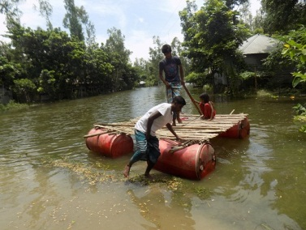
- Affected HH has lost their lands including home stead, crops, latrine, Tub-wells, homestead plantation- garden etc by river erosion. They are also badly affected by flood.
- Cattle house have fully damage in affected areas.
- Maximum crops land have inundated by flood and Vegetable garden goes under water/fully damages by river erosion.
- Fodder, goes under water in this situation they are ready to sale their cattle, goat and sheep within a minimum rate.
- Homestead based goods couldn’t shifted to other places except tin, rice bag, Khat etc.

Problems and sufferings

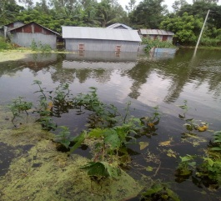
- Peoples mobility and overall livelihood: Overall mobility of char communityhave limited. The families affected by riverbank erosion they are facing problems for managing land for house reconstruction. On the other hand, people have suffering for daily livelihood work, because their job opportunity becomes closed. They have to spend their saving and some more vulnerable HH sell their livelihood asset (cattle, goat etc) or sell labor in advance for surviving.Lack of shelter for cattle also, cattle keeping under open sky is risky. They have no security to safe their livelihood assets.
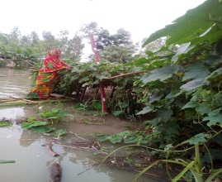
- Crops and fodder :Field based crop and vegetable has fully gone under flood water, specially, 100% seedbed has damage in affected areas and about 30% homestead garden has damaged. Most of the fodder land gone under water in the affected areas. During the flood community people are facing the crisis of fodder.
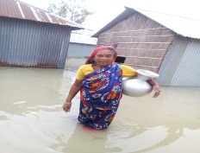
- WATSAN: Water, sanitation and hygiene(WASH) are completely disconnected to affected areas.Most of the latrines and tub-wel have gone under water.Toilet problem has become very bashful for the women, adolescents and older person in affected areas.Problems for maintaining daily lives like cooking, eating, domestic work, using toilets. They have risk on health care specially water borne disease.

- School Institute : Most of the school in char has inundated due to sudden flood. As mobility of char dwellers have been restricted so student’s attendance rate ges down. As flood water is everywhere, so parents don’t dare to send their children to school

(Source: HH/Village visit data, Union Parishad data, Volunteer, social elites, Primary information from community)

Immediate need for affected community:
- Mainly need to clean water sources (Tube-well) in order to have water for use and consumption
- Installation of latrine and mobile toilet facilities in shelters.
- Raising tube-wells, Cleaning tube-wells
- Nonfood items like water pot, plate, Mag, crockeries items, cloths Hygiene kits for women including sanitary Pad/Napkins, shops etc for the families affected by riverbank erosion
- People are in need of sleeping mats, purification tablets, tarpaulin sheets, Shelter materials for river
- Most of the school in char has inundated due to sudden flood.
- Cash grant

Humanitarian support provided or initiatives taken so far: Local Administration started distribution rice and cash for the affected communities. During the repotting time, total 338 mt rice, 900000/- cash, dry food 2000pack already distributed in Sirajgoanj by district administration. In Bogra, Pabna and Tangil District authority also started distribution of rice, cash and dry food.

Emergency supports and services providing so far
- MMS is collecting information; prepare situation report and disseminating to respective sectors and department.
- We formed a search and rescue team who are doing search and rescue the affected people and shifting to safer place.

Rafiq Khan
Deputy Director
MMS

